***OOP LAB ASSIGNMENT = 3***

Name :- Ankit Senjaliya

Enrollment No. :- 19BT04046

(1)Write a C++ program to show the working copy constructor (implicitly and explicitly).

#include<iostream.h>

#include<conio.h>

class A

{

private: int num1,num2;

public: A(int n1, int n2)

{

num1 = n1;

num2 = n2;

}

void display()

{

cout<<"\n\n\t\t\t Num 1 = "<<num1<<endl;

cout<<"\n\n\t\t\t Num 2 = "<<num2<<endl;

}

};

int main()

{

clrscr();

cout<<"\n\n\t\t\t Name :- Ankit Senjaliya ";

cout<<"\n\n\t\t\t Enrollment No. :- 19BT04046 \n\n";

A obj(20,25);

obj.display();

getch();

return 0;

}

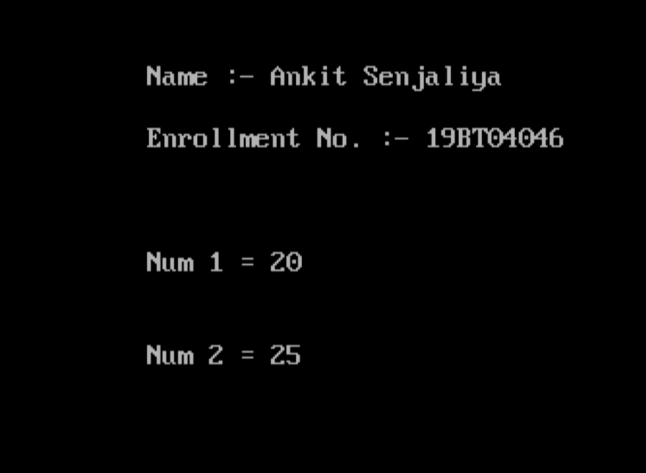

(2) Write a C++ program to demonstrate a concept of array of an object for student grade results.

#include<iostream.h>

#include<conio.h>

#define MAX 15

class student

{

private:

char name[20];

int rollno;

int total;

float percentage;

public:

void getDetails(void);

void putDetails(void);

};

void student::getDetails(void)

{

cout<<"\n\n\t Enter Name = ";

cin>>name;

cout<<"\t Enter Roll No. = ";

cin>>rollno;

cout<<"\t Enter Total Marks Out Of 700 = ";

cin>>total;

percentage=(float)total/700*100;

}

void student::putDetails(void)

{

cout<<"\n\n\t\t\t Student Details = ";

cout<<"\n\n\t Name = "<<name;

cout<<"\n\t Roll No. = "<<rollno;

cout<<"\n\t Total = "<<total;

cout<<"\n\t Percentage = "<<percentage;

}

int main()

{

clrscr();

cout<<"\n Name :- Ankit Senjaliya ";

cout<<"\n Enrollment No. :- 19BT04046 \n\n";

student std[MAX];

int n,i;

cout<<"\n\n\t\t\t Enter Total Number Of Student = ";

cin>>n;

for(i=0;i<n;i++)

{

cout<<"\n\t\t Enter Details Of Student = "<<i + 1;

std[i].getDetails();

}

cout<<endl;

for(i=0;i<n;i++)

{

cout<<"\n\t\t Details Of Student = "<<(i + 1);

std[i].putDetails();

}

getch();

return 0;

}

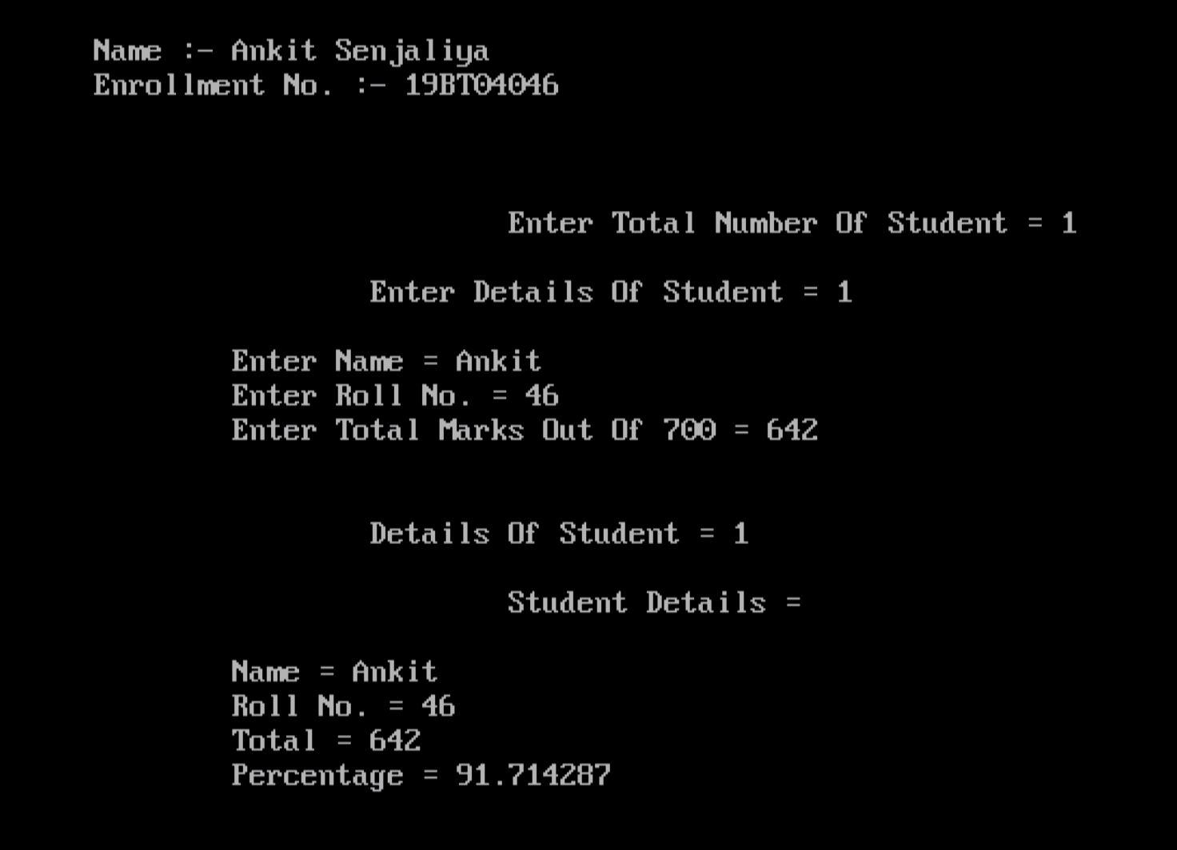

(3) Write a C++ program to demonstrate use of constructor with default argument (Give 2-3 variations with constructor overloading concept).

#include<iostream.h>

#include<conio.h>

class Area

{

private:

int length;

int breadth;

public:

Area(): length(10), breadth(12)

{

}

Area(int l, int b): length(l), breadth(b)

{

}

void GetLength()

{

cout<<"\n\n\t\t\t Enter Length = ";

cin>>length;

cout<<"\n\n\t\t\t Enter Breadth = ";

cin>>breadth;

}

int AreaCalculation()

{

return length * breadth;

}

void DisplayArea(int temp)

{

cout<<"\n\n\t\t\t Area = "<<temp<<endl;

}

};

int main()

{

clrscr();

cout<<"\n\n\t\t\t Name :- Ankit Senjaliya ";

cout<<"\n\n\t\t\t Enrollment No. :- 19BT04046 \n\n";

Area A1, A2(3,5);

int temp;

cout<<"\n\n\t\t\t Default Area When No Argument Is Passed = "<<endl;

temp = A1.AreaCalculation();

A1.DisplayArea(temp);

cout<<"\n\n\t\t\t Area When (3,5) Is Passed As Argument = "<<endl;

temp = A2.AreaCalculation();

A2.DisplayArea(temp);

getch();

return 0;

}

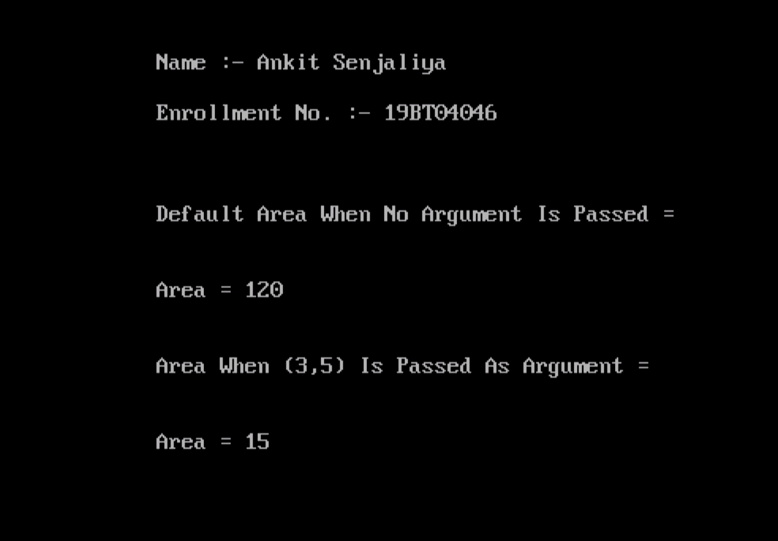

(4) Write a C++ program to justify the usage of destructor.

#include<iostream.h>

#include<conio.h>

class ABC

{

public:

ABC()

{

cout<<"\n\n\t\t\t Constructor Is Called = ";

}

~ABC()

{

cout<<"\n\n\t\t\t Destructor Is Called = ";

}

};

int main()

{

clrscr();

cout<<"\n\n\t\t\t Name :- Ankit Senjaliya ";

cout<<"\n\n\t\t\t Enrollment No. :- 19BT04046 \n\n";

ABC cc1;

cout<<"\n\n\t\t\t Function Main Is Terminating... ";

getch();

return 0;

}

